**ITA1447-ETHICAL HACKING**

**Exercise No 1:** **Nmap Scan TMA.HEMANT(192110398)**

**Aim:**

To install and perform Nmap scan (note :- you may use ip address or website name)

**Procedure:**

Step 1: Open Nmap from Kali Linux (Goto Applications->select Information Gathering->select

Nmap)

Step 2: Perform different types of scan

(Tcp, Udp, Ack, Syn, Fin, Null, Xmas, Rpc, Idle)- scan types

**Scanning Techniques**

|  |  |  |
| --- | --- | --- |
| **Flag** | **Use** | **Example** |
| **-sS** | **TCP syn port scan** | **nmap -sS 192.168.1.1** |
| **-sT** | **TCP connect port scan** | **nmap -sT 192.168.1.1** |
| **–sU** | **UDP port scan** | **nmap –sU 192.168.1.1** |
| **–sA** | **TCP ack port scan** | **nmap –sA 192.168.1.1** |

Step 3:-

To perform host discovery

|  |  |  |
| --- | --- | --- |
| -Pn | only port scan | nmap -Pn192.168.1.1 |
| -sn | only host discover | nmap -sn192.168.1.1 |
| -PR | arp discovery on a local network | nmap -PR192.168.1.1 |
| -n | disable DNS resolution | nmap -n 192.168.1.1 |

Step4:-

**Port Specification**

|  |  |  |
| --- | --- | --- |
| **Flag** | **Use** | **Example** |
| **-p** | **specify a port or port range** | **nmap -p 1-30 192.168.1.1** |
| **-p-** | **scan all ports** | **nmap -p- 192.168.1.1** |
| **F** | **fast port scan** | **nmap -F 192.168.1.1** |

Step 5:-

***Service Version and OS Detection***

|  |  |  |
| --- | --- | --- |
| Flag | Use | Example |
| -sV | detect the version of services running | nmap -sV 192.168.1.1 |
| -A | aggressive scan | nmap -A 192.168.1.1 |
| -O | detect operating system of the target | nmap -O 192.168.1.1 |

Step 6:-

Timing and Performance

|  |  |  |
| --- | --- | --- |
| Flag | Use | Example |
| -T0 | paranoid IDS evasion | nmap -T0 192.168.1.1 |
| -T1 | sneaky IDS evasion | nmap -T1 192.168.1.1 |
| -T2 | polite IDS evasion | nmap -T2 192.168.1.1 |
| -T3 | normal IDS evasion | nmap -T3 192.168.1.1 |
| -T4 | aggressive speed scan | nmap -T4 192.168.1.1 |
| -T5 | insane speed scan | nmap -T5 192.168.1.1 |

Output:

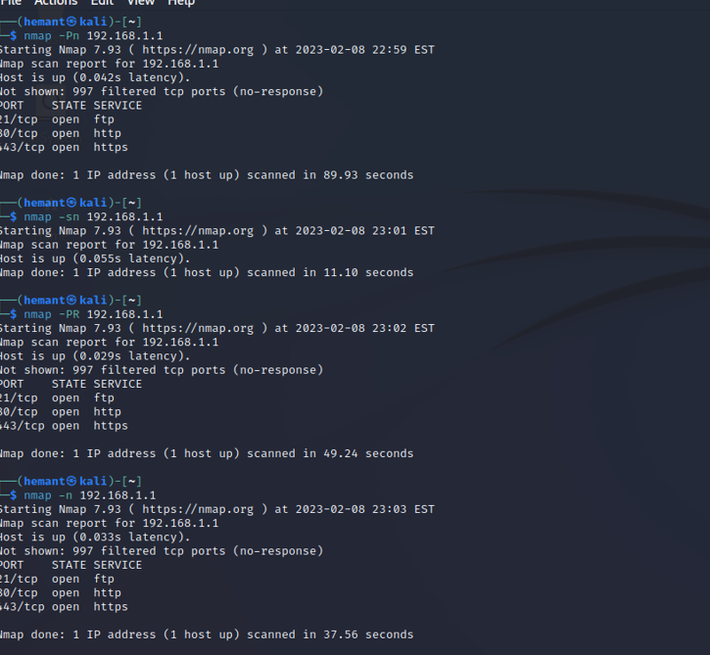

Result:

Hence the map scan performed successfully.